**CREATE A CHATBOT IN PYTHON**

**Phase 1: Document Submission**

**Team detail**

962821106036: KAILASH T (Team Leader)

962821106024: DHANUSH THIVAKAR P

962821106038: MAHAANT M P

962821106047: PUVIARASAN M

962821106304: JERVIN S

**Project Title: Create Chatbot in Python**

**OBJECTIVE:**

The objective of the project is to develop a chatbot by using the Python programming language. It behaves to the human being friendly. It has also able to understand the human mentality based on their queries and it will reply them exactly or relevantly according to their questions.

**Phase 1: Problem Definition and Design Thinking**

**Problem Definition:**

To create a chatbot in python that has able to provide the customer service, answering user queries on a website or application. It’s main aim is to deliver high quality support to users, ensuring a positive user experience and customer satisfaction.

Dataset link: https://www.kaggle.com/datasets/grafstor/simple-dialogs-for-chatbot

**Conversation between the Human and Chatbot:**

1. Greeting:

Human: "Hello!"

Chatbot: "Hi there! How can I assist you today”

1. Seeking Assistance:

Human: "I need help with my account."

Chatbot: "Of course, I can help you with that. What specifically do you need assistance with?"

1. Complaint Handling:

Human: "I'm not satisfied with your service."

Chatbot: "I apologize for the inconvenience. Can you please provide more details about the issue so I can assist you better?"

1. Providing Instructions:

Human: "How do I reset my password?"

Chatbot: "To reset your password, please go to our website, click on 'Forgot Password,' and follow the instructions."

**Design and Thinking:**

**1.User Interaction:**

Our chatbot interacts with users through text conservations. Users can send messages to the chatbot, and it response accordingly.

**Text-Based Chat Interface**:

We use most common and straightforward chatbot UI. Users type their questions or messages, and the chatbot responds with text. You can use chat bubbles for the conversation, similar to messaging apps.

**2. Natural Language Processing:**

We will implement the Natural Language Processing (NLP) that enables the chatbot to understand and respond to user input in a human-like way. NLP in chatbots is an iterative process. Continuously update and train our NLP models with new data and user interactions to improve their understanding and response quality.

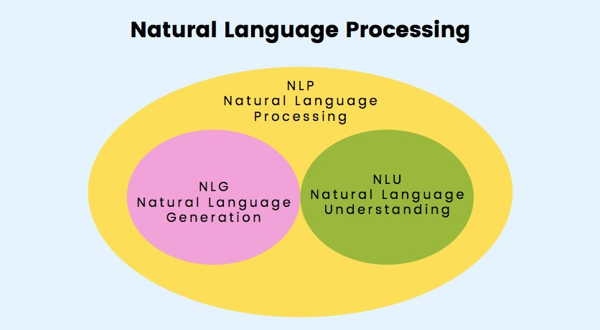

**i . Natural Language Generation (NLG):**

We use the NLG systems to transform the data or information into human-readable and comprehensible language. NLG algorithms analyse the input data and use predefined rules, templates, or machine learning models to generate natural language text. This text can include sentences, paragraphs, or even longer documents.

**ii. Natural Language Understanding (NLU):**

We use the NLU techniques to understand the user’s input. This involves parsing the text to identify the user’s intent, extract relevant information and determine the context of the conservation. NLU systems are designed to handle ambiguity in language, disambiguating phrases or words with multiple meanings based on the context.

**Scalability**:

NLU allows chatbots to handle a wide range of user inputs and intents, making them scalable for various use cases and industries.

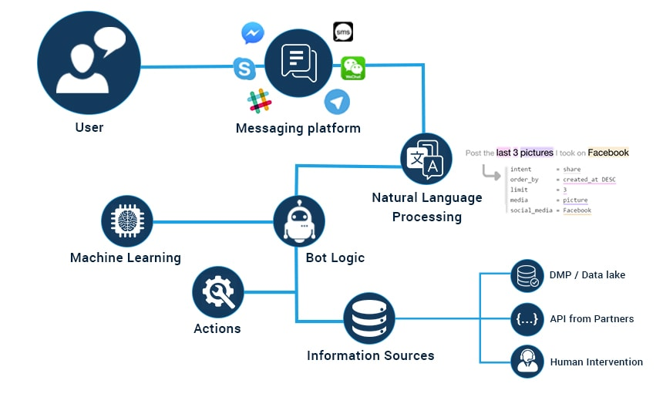**PYTHON PROGRAM:**

import nltk

from nltk.chat.util import Chat, reflections

# Define a list of patterns and responses for the chatbot

patterns = [

(r'hi|hello|hey', ['Hello!', 'Hi there!', 'Hey!']),

(r'how are you', ["I am just a chatbot, but I'm here to help!", "I'm doing well. How can I assist you today?"]),

(r'what is your name', ["I'm just a chatbot.", "I don't have a name."]),

(r'bye|goodbye', ['Goodbye!', 'Take care!', 'See you later!']),

(r'help', ['I can assist you with general information and questions. Just ask!']),

(r'(\w+) help', ['Sure, I can help with that. What do you need assistance with regarding {0}?']),

(r'(\w+) (resource|link)', ['I can provide resources. What specific {0} are you looking for?']),

(r'(\w+) (website|site)', ['You can visit the website for {0} at https://example.com/{0}']),

(r'(\w+) (information|info)', ['I can provide information on {0}. What would you like to know?']),

]

# Create a chatbot using the patterns and reflections

chatbot = Chat(patterns, reflections)

# Start the conversation

print("Hello! How can I assist you today? (type 'quit' to exit)")

while True:

user_input = input("You: ")

if user_input.lower() == 'quit':

break

response = chatbot.respond(user_input)

print("Chatbot:", response)

**OUTPUT:**

Hello! How can I assist you today? (type 'quit' to exit)

You: hi

Chatbot: Hello!

You: how are you

Chatbot: I am just a chatbot, but I'm here to help!

You: what is your name

Chatbot: I'm just a chatbot.

You: help

Chatbot: I can assist you with general information and questions. Just ask!

You: tell me more about Python

Chatbot: I can provide information on Python. What would you like to know?

You: Python resources

Chatbot: I can provide resources. What specific Python resources are you looking for?

You: tutorials

Chatbot: You can visit the website for Python tutorials at https://example.com/tutorials

You: bye

Chatbot: Goodbye!

**Integration:**

We develop a Chatbot through the website. We develop a web - based chatbot typically from the web development skills like HTML, CSS, Java script.

**Scalability:**

Our web-based chatbots can be easily scaled to accommodate a large number of users since they don't rely on device-specific installations**.**

**Analytics:**

Our website chatbots often benefit from web analytics tools for tracking user interactions and improving the user experience.

**Accessibility:**

Our web-based chatbot is accessible from any device with a web browser, making them more versatile in terms of device compatibility.

**Ease of Access:**

Users don't need to install a separate application; they can access the chatbot directly from their web browser, which can lead to a lower barrier to entry.

**Conclusion:**

The development of a chatbot on a website is a versatile and powerful solution for enhancing user experiences, providing assistance, and automating interactions. It works as a strong and positive bond between a chatbot and a user is crucial for creating a successful and engaging interaction.